

FACULTY OF INFORMATION COMMUNICATION TECHNOLOGY
DEPARTMENT OF INFORMATION COMMUNICATION TECHNOLOGY
YEAR: 2025

By:
Ondela Skwatsha
ST20454909
(Monthly Claim System )

Lecturer
Miss Andiswa Phewa

September 2025

Table of Contents
Introduction 2
Components of the project: 2
Project Plan: 2
UML Class diagram: 3
Graphic user interface: 4

Introduction
This project presents how the initial design and planning phases of the Contract Monthly Claim System have been done. This system is a digital solution aimed at streamlining the submission, verification, and approval of monthly claims by contract lecturers. This system is meant to enhance the transparency, efficiency, and user experience across academic departments by providing a centralized platform for managing claim-related activities.

Components of the project:
- Database design: A UML class diagram will be used to show data structures and capturing essential entities such as lecture, claim, document, approval, and role/user
- Project planning: A detailed project plan is used to outline the development timeline, task dependencies, and milestones to ensure that the is a realistic and achievable goal.
- Graphic user interface: WPF with .NET Core is used to present the front-end development of the project

Project Plan:

This project plan uses a Gantt chart that includes tasks, durations, milestones, and a timeline to visually map out the project schedule.
Key Components:
- Project Tasks/Activities: These are the individual work items or steps needed to complete the project. Each task is listed on the vertical axis of the Gantt chart.
- Task Duration: Start and end dates or durations are assigned to each task, represented as horizontal bars spanning the timeline. This illustrates how long a task will take.
- Timeline/Schedule: The horizontal axis shows the timeline, which can be days, weeks, or months, depending on project length, enabling clear visualization of when tasks start and finish.
- Milestones: Special markers indicating significant events or deadlines in the project. Milestones usually have zero duration and highlight key points like phase completions or deliverable submissions.
- Dependencies/Task Relationships: Arrows or lines that connect tasks to show dependencies, such as which tasks must be finished before others can begin. This helps identify critical paths and sequencing.
- Resources: Sometimes included to show who or what is assigned to each task (e.g., team members, equipment), helping manage workload and accountability.
- Progress Tracking: Many Gantt charts also show completed percentages or progress bars within the task bars, providing a real-time view of the project's status.

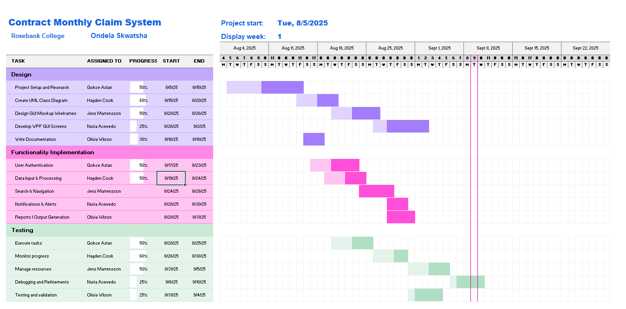

UML Class diagram:

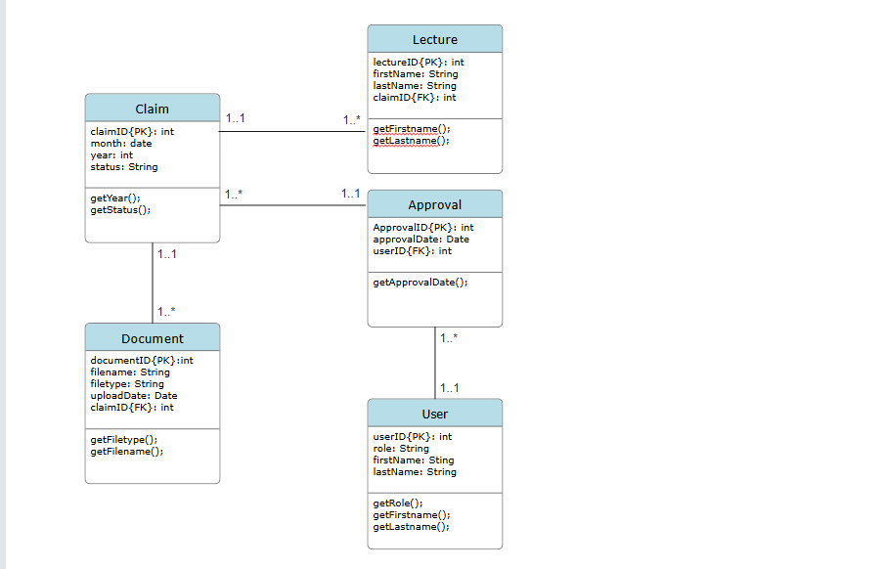

Business rules:
- A lecture submits many claims
- A claim has many documents
- A claim gets approved
- A user makes approvals

Graphic user interface:

Screenshots:
Login:

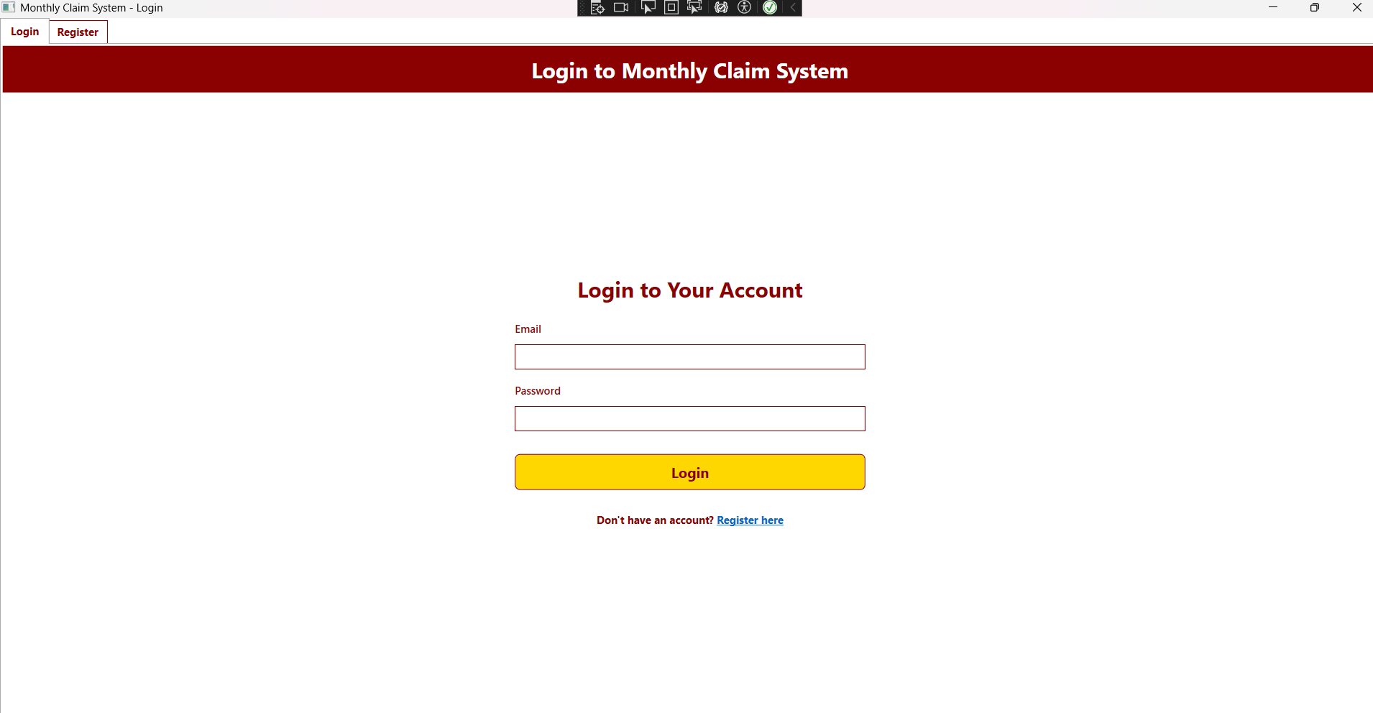

Register:
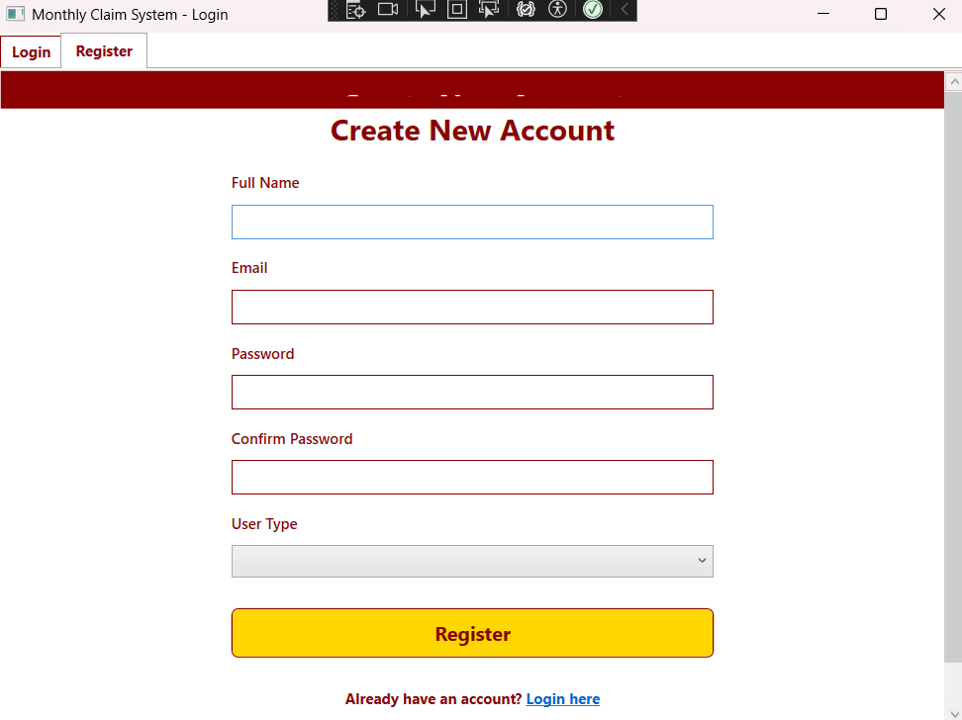
Dashboard:
Claim History:
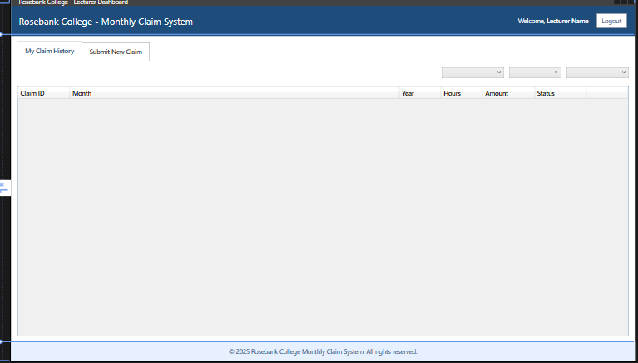

Submit New Claim:
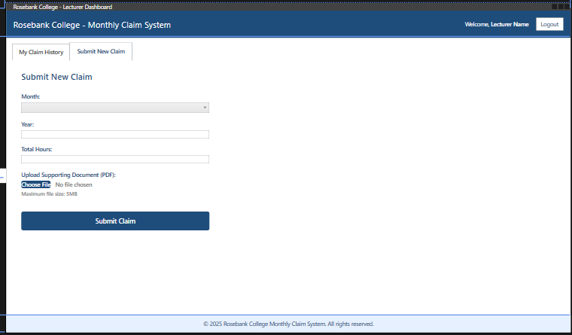

Assumptions:
- The project will use an internal system for the Rosebank College staff
- The users will need their Rosebank College credentials
- The users will be able to view their claim history

Constraints:
- The authentication system needs integration with the colleges user directory
- The file uploads will be restricted to pdf format with size limit
- The responsive design will need to be done for various device sizes

Key Features:
It is split it into two main parts:
- Viewing past claims - made a table that shows everything at once
- Submitting new claims - kept the form simple with dropdowns so people don't mess up
This design helps lecturers quickly do what they need without getting confused. The college gets proper documentation with all the right info. And it looks slick and professional, which is important for a college system.

The background colours used are red, white and blue.
GitHub Link:
https://github.com/ondelaskwatsha/ClaimSystem.git

PART 1 IMPROVEMENTS:

The GUIs have been changed and improved for the ones below:
Login:
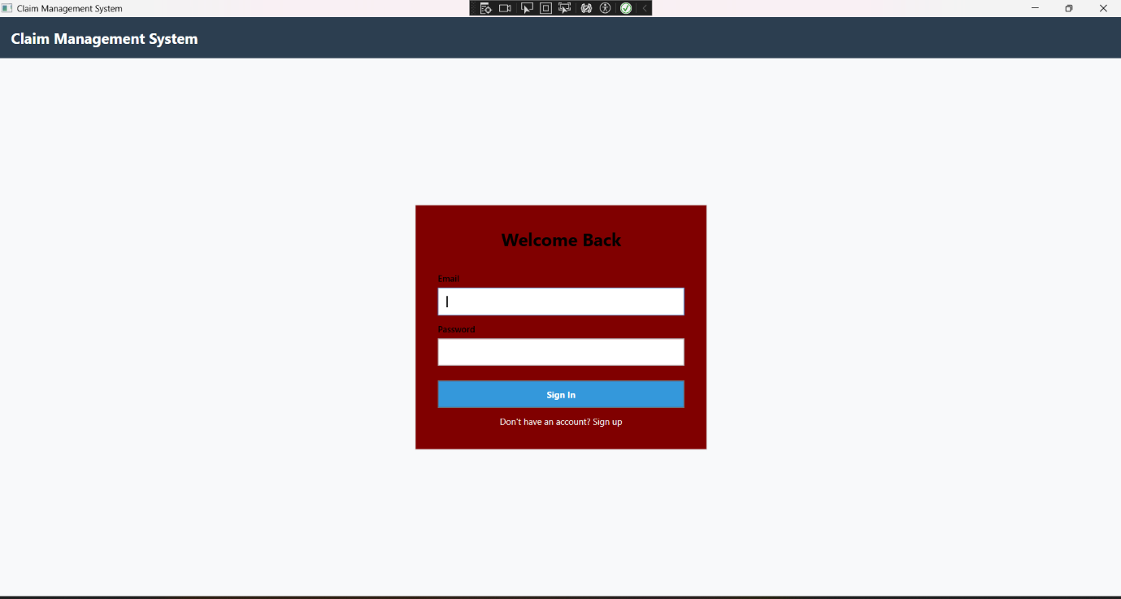

Registration:
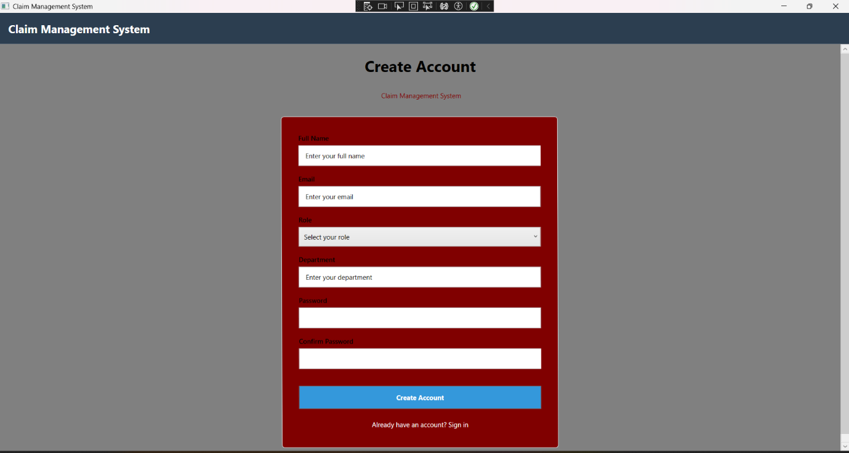

Coordinator Dashboard:
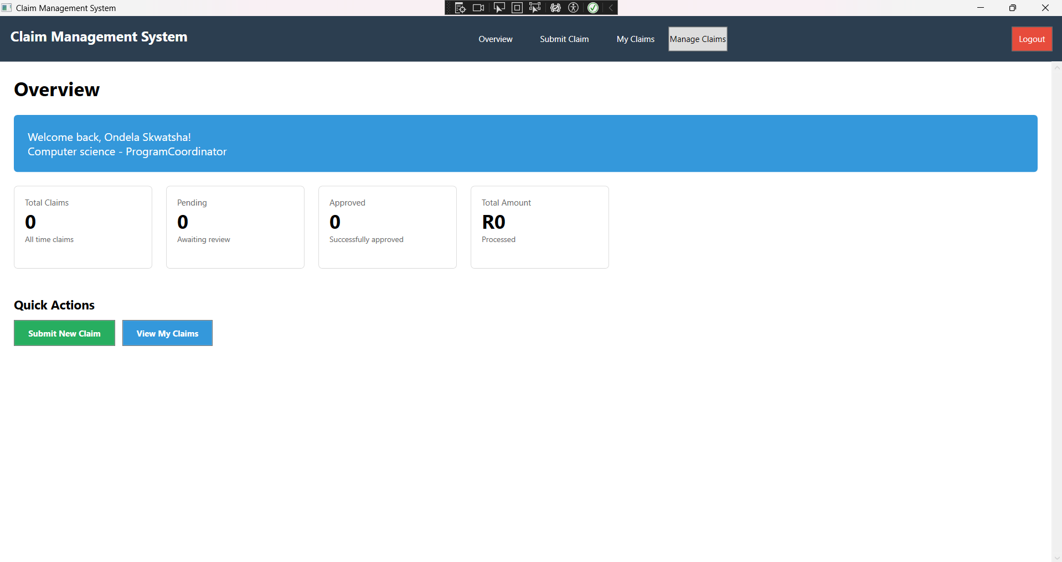
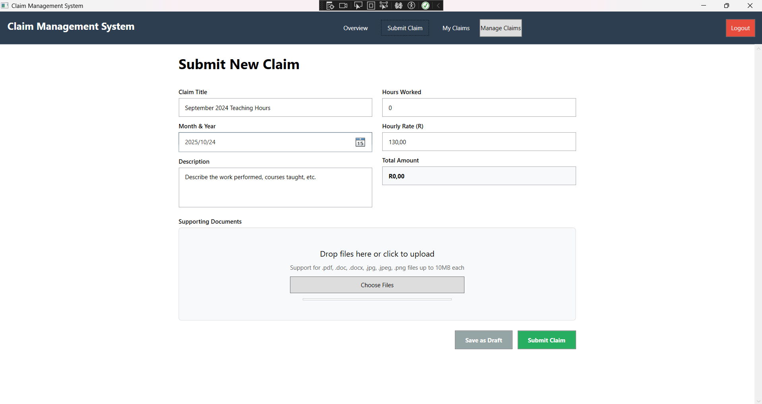
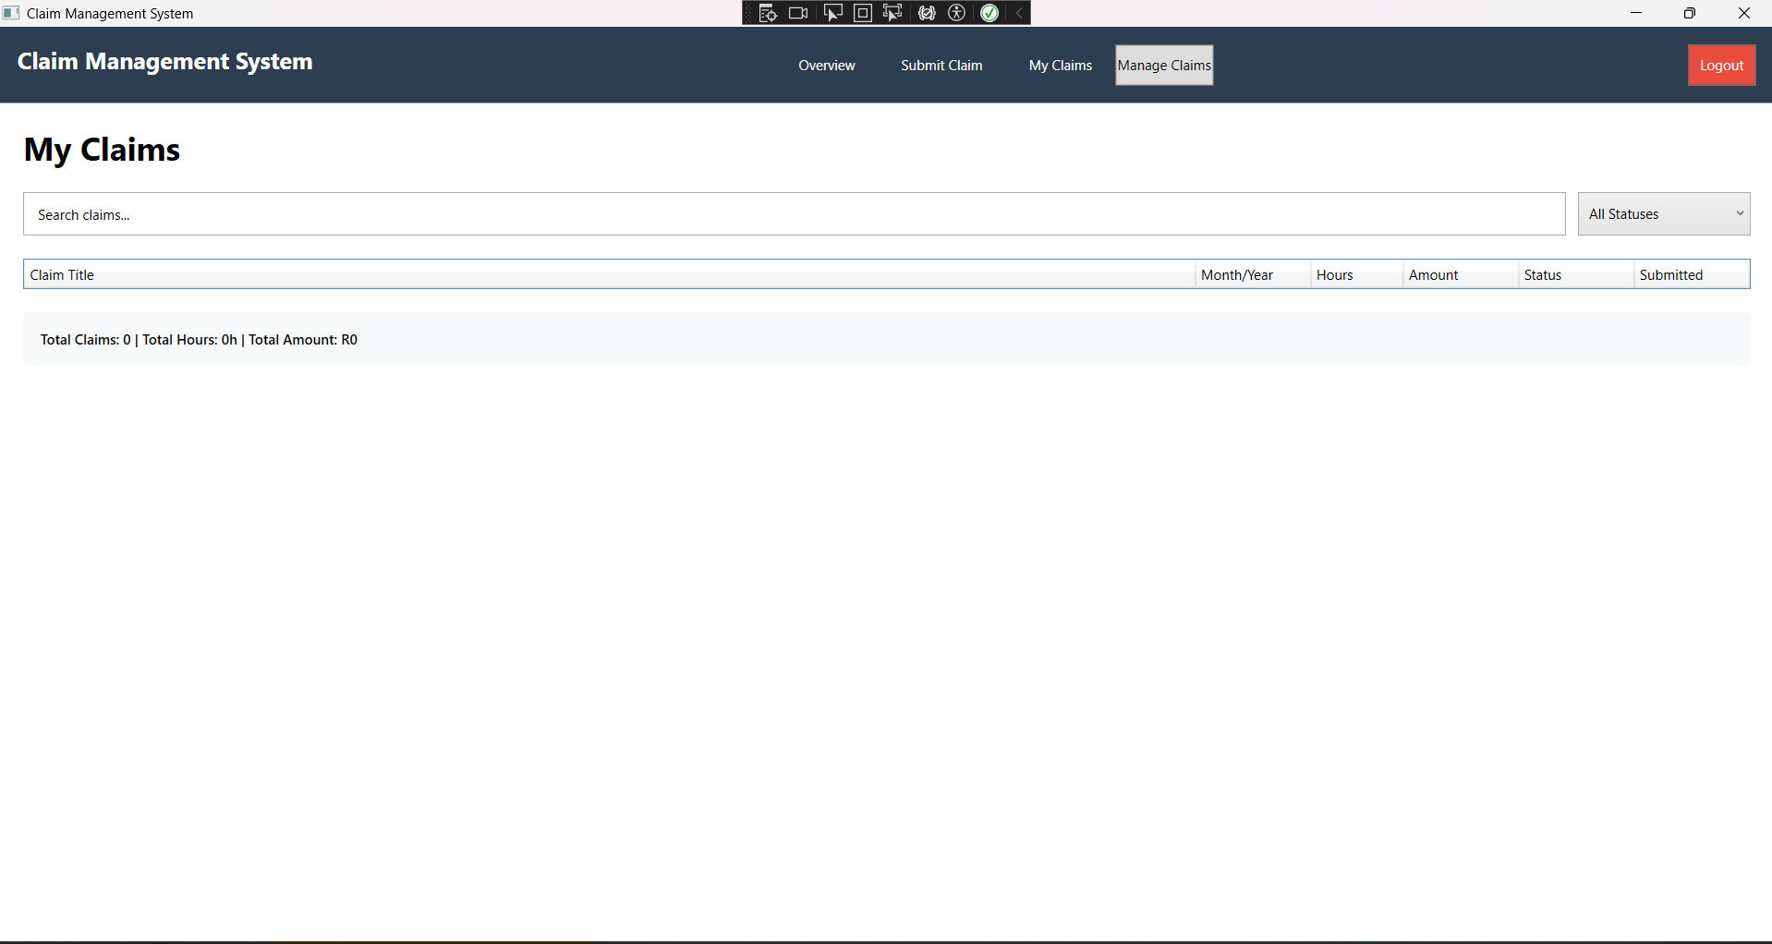
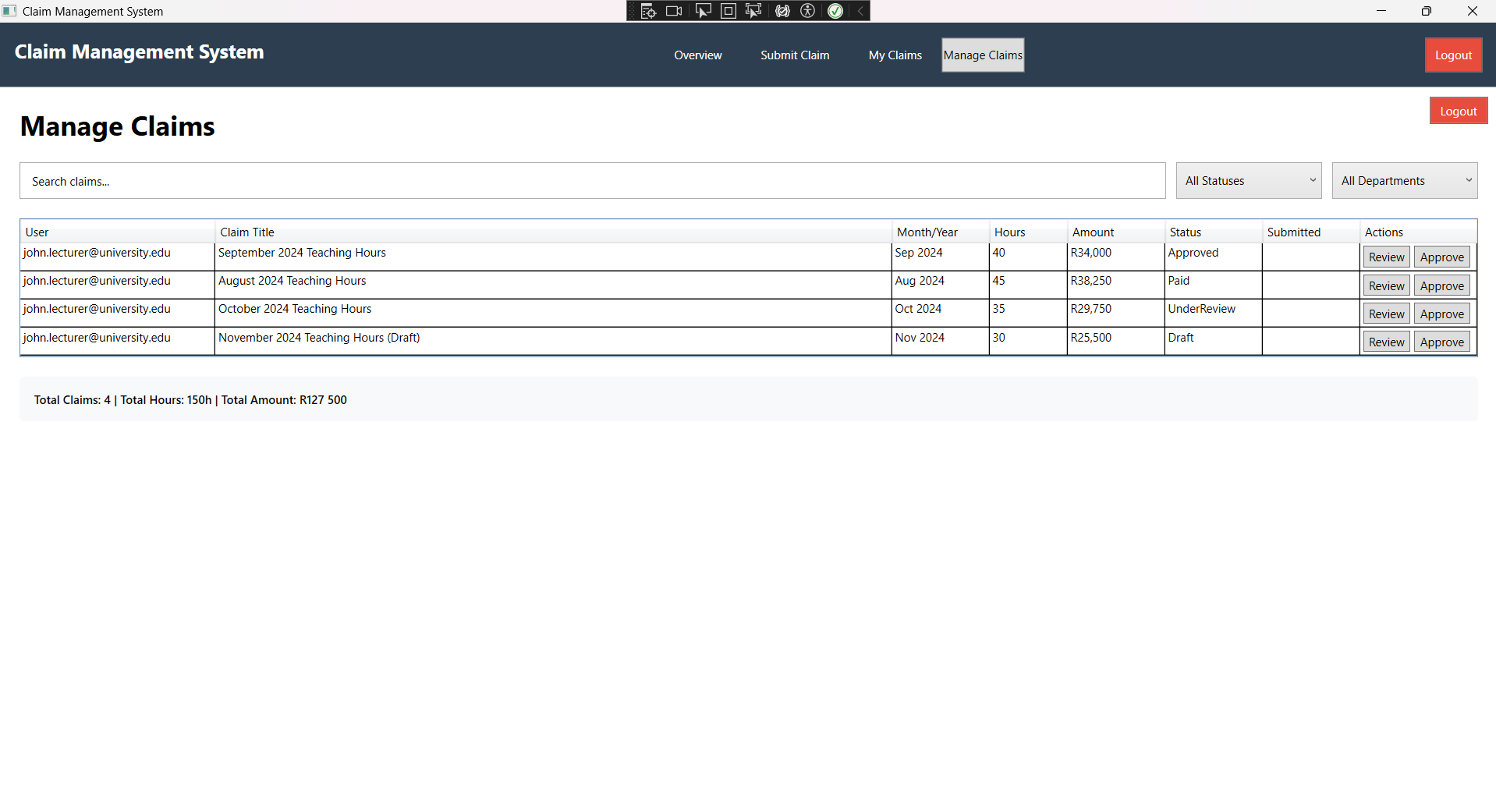

Lecture dashboard:
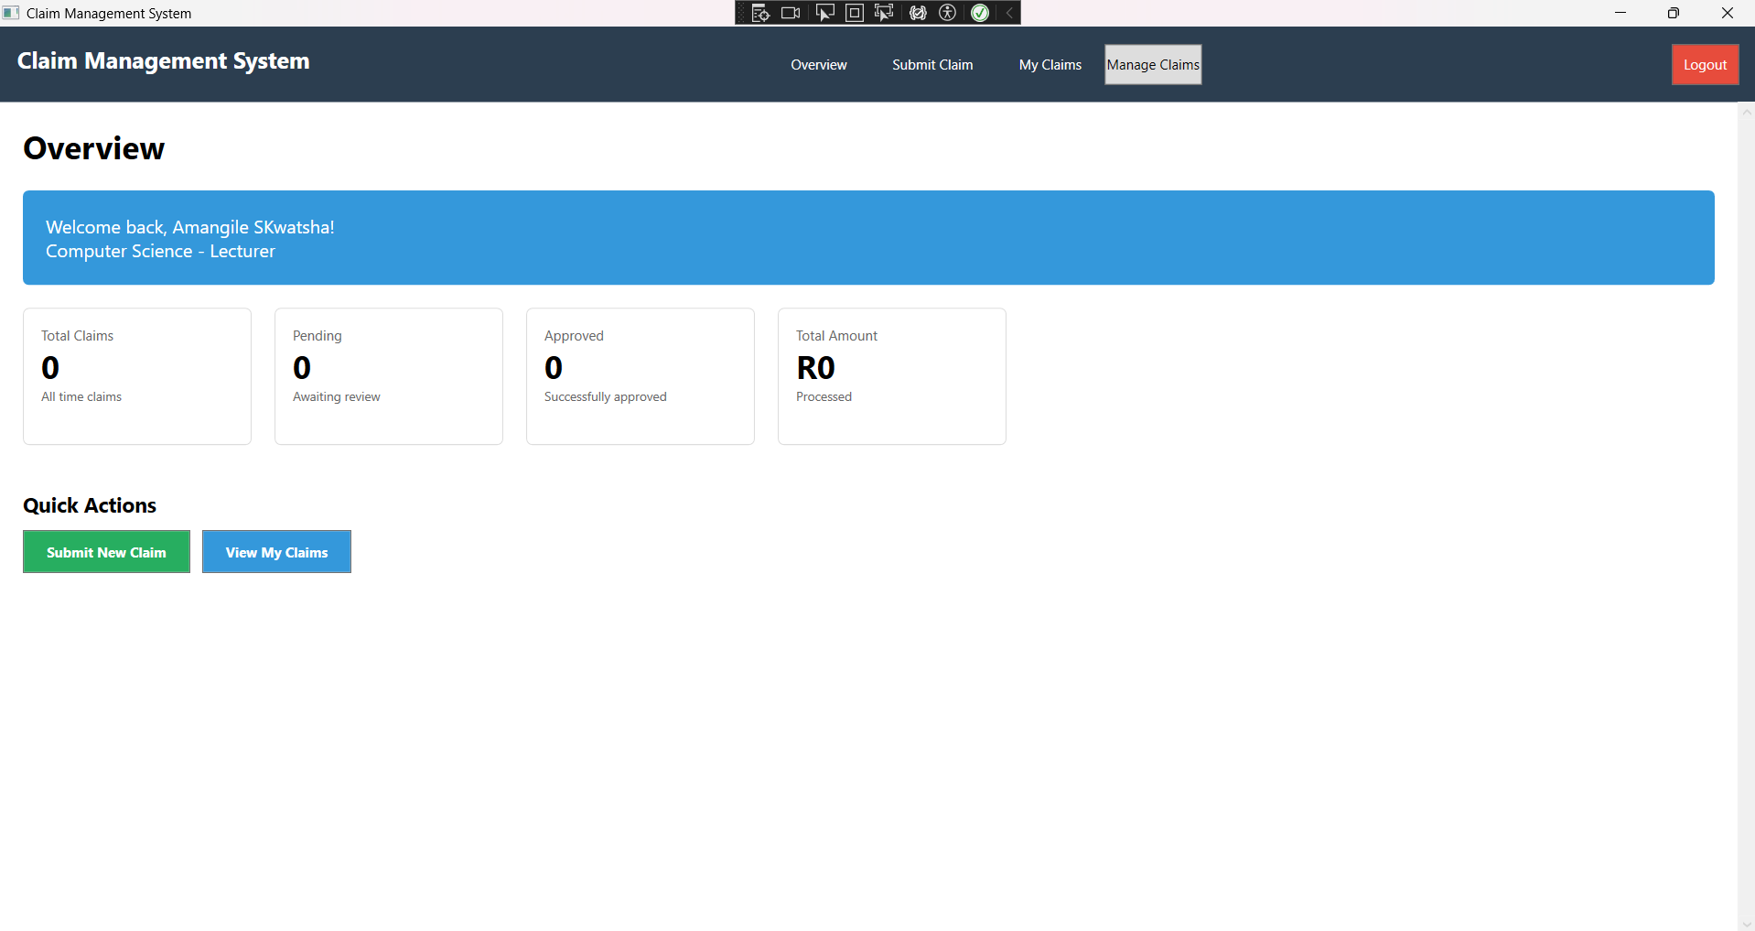

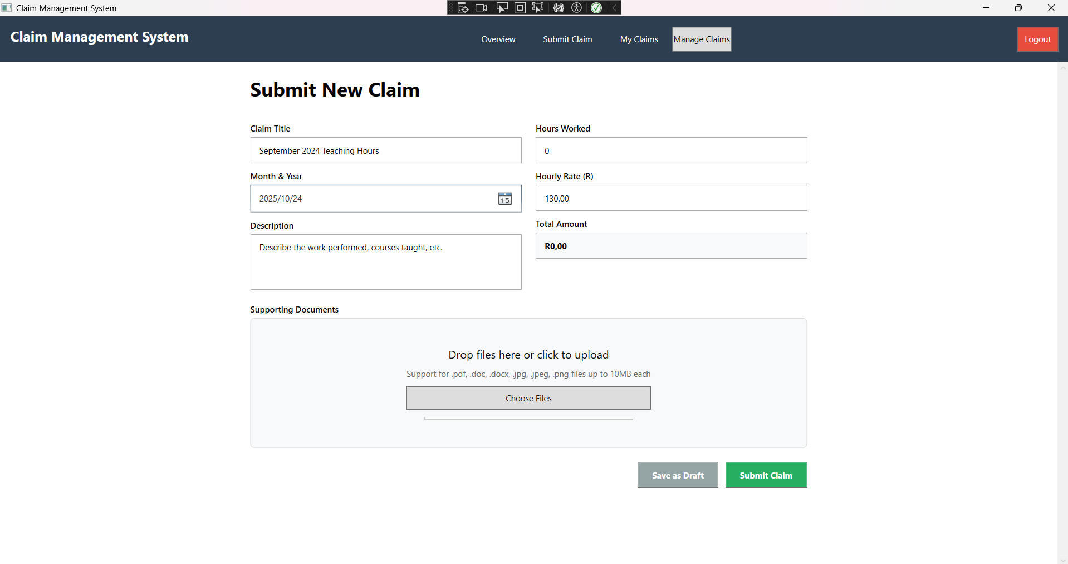
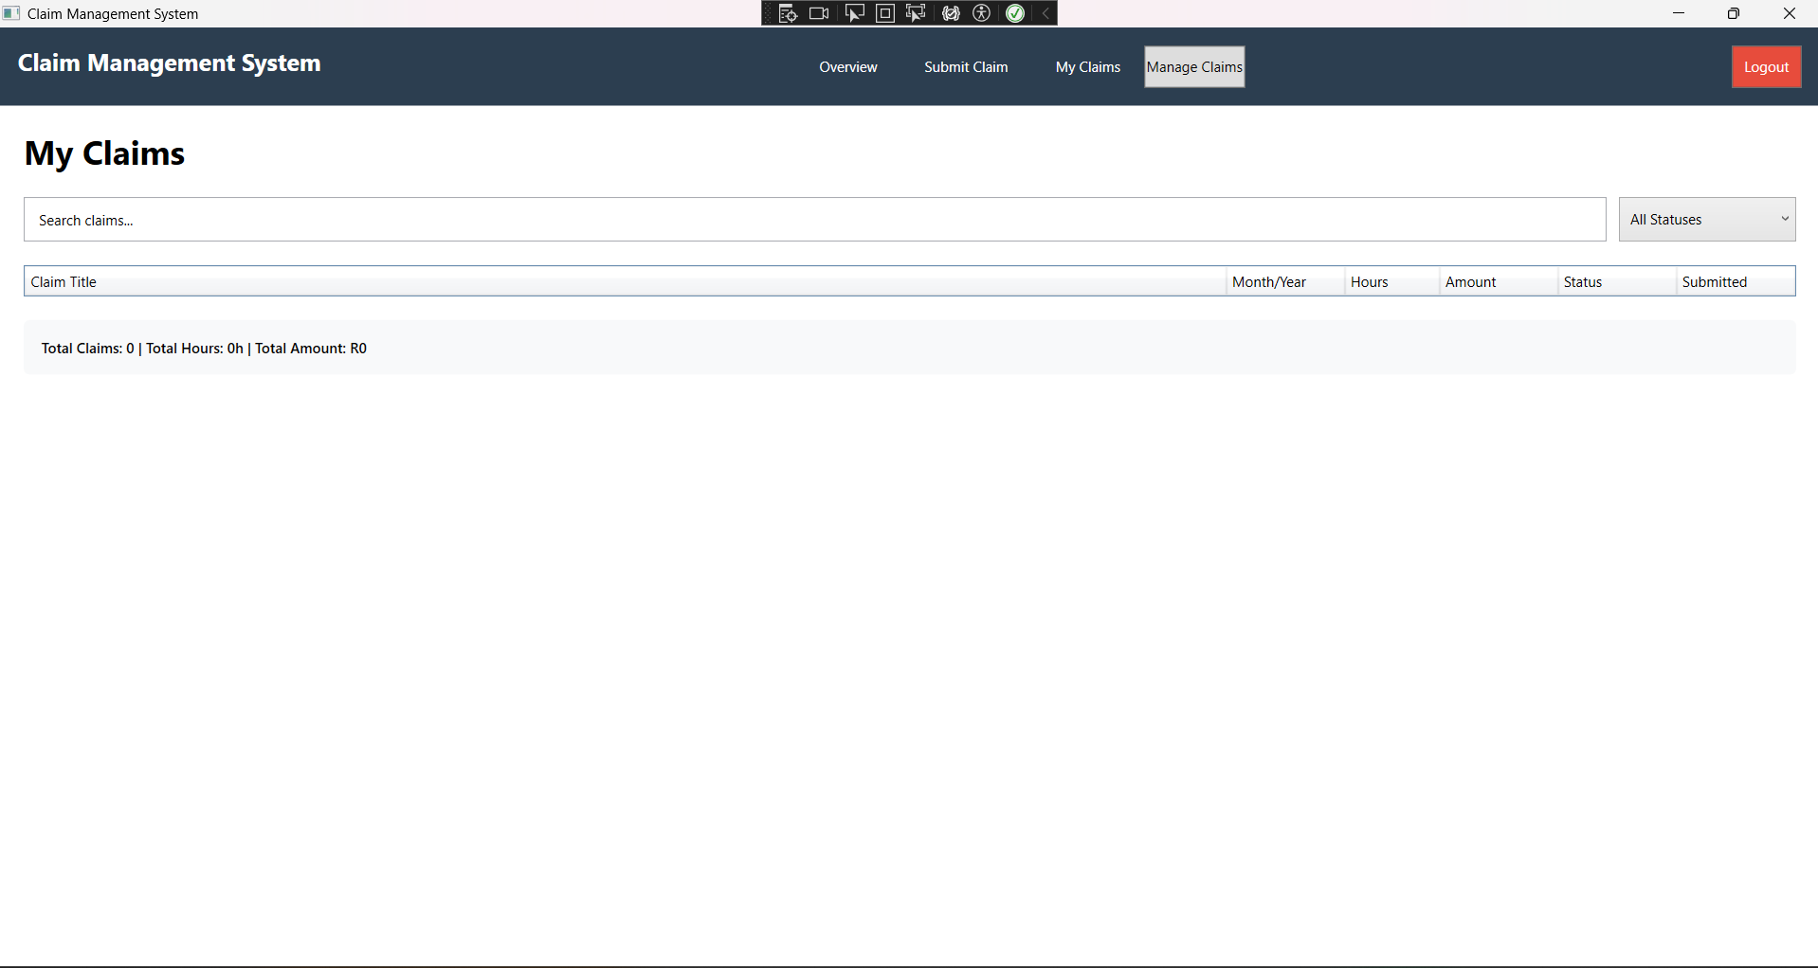
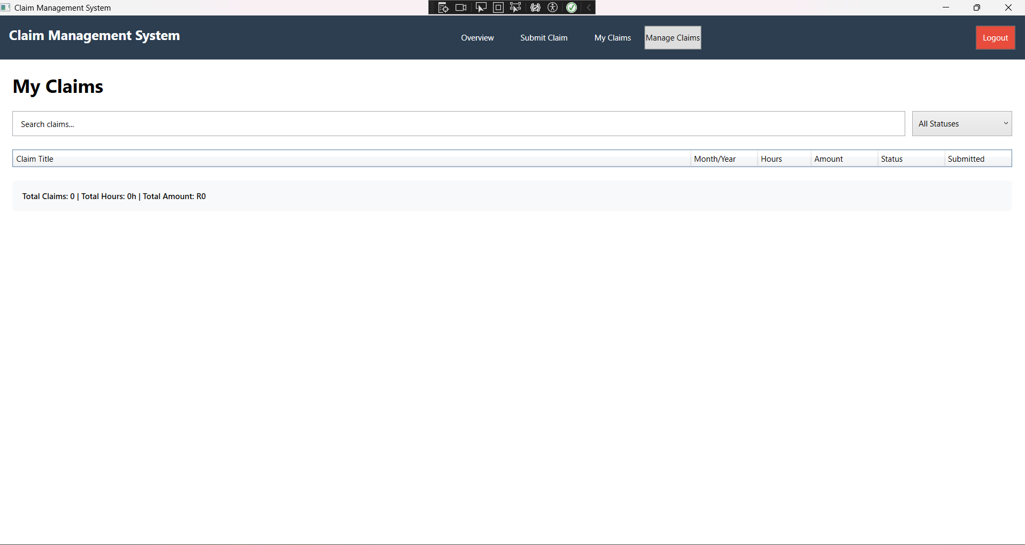
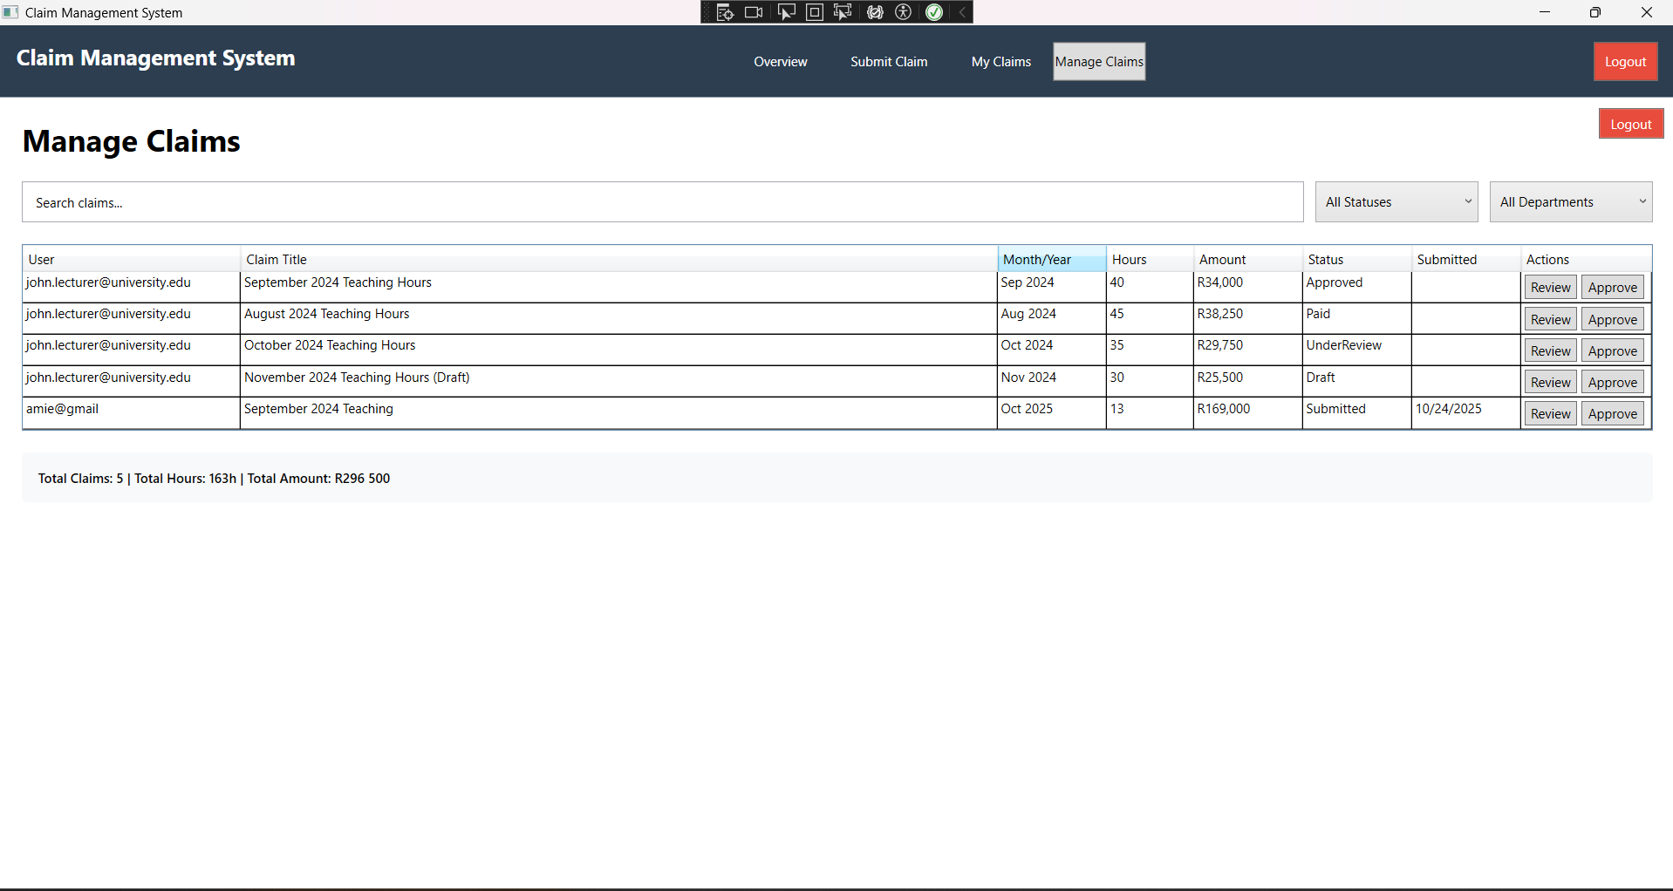

Manager Dashboard:
